Alternative Car Park Locations and Public Transport to Ewood Park
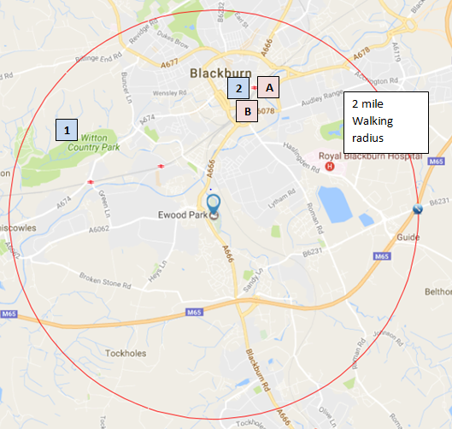

Point | Free Car Parks | Location | Public Transport and Walking Options to Ewood Park
1 | Witton Country Park | 1 mile from Blackburn Town Centre, on Preston Old Road (A674) heading towards Preston. | PUBLIC TRANSPORT  Step 1- Take the Hotline 152 bus to Blackburn Bus Station. Operates every hour from outside Witton Park  Timetable for Hotline 152  Step 2 – Take the Number 1 bus from Blackburn Bus Station to Ewood Park. Operates every 15-20 minutes. Approximately a 7 minute journey  Timetable for Number 1  WALKING  Walking to Ewood Park from Witton Park is approximately 1.7 miles taking around 30-40 minutes.
2 | Blackburn Town Centre – Council Car Parks:  - Brown Street (120 spaces)  - Starkie Street (120 spaces)  - Salford (70 spaces)  For locations of these car parks visit:  Car Park Location Map  Other Council owned car parks are available in Blackburn Centre; please visit the ‘Car Park Location Map’ above for further details. | Brown Street, Starkie Street and Salford Car Parks are all ideally located within close proximity to Blackburn Bus Station. | PUBLIC TRANSPORT  Take the Number 1 bus from Blackburn Bus Station to Ewood Park, approximately a 7 minute journey, operating every 15-20 minutes  Timetable for Number 1  WALKING  Walking to Ewood Park from Blackburn Town Centre is approximately 1.7 miles, taking around 30-40 minutes.
Public Transport Facilities
A | Blackburn Rail Station | Town Centre Location in close proximity to Blackburn Bus Station | If arriving into Blackburn by rail, stand number 1 is directly outside the rail station to then take the number 1 bus direct to Ewood Park.
B | Blackburn Bus Station | Town Centre Location | Number 1 bus service direct to Ewood Park.
NOTE: The Number 1 bus operates along the A666 into Darwen therefore can be used if coming from the Darwen Area/Direction

