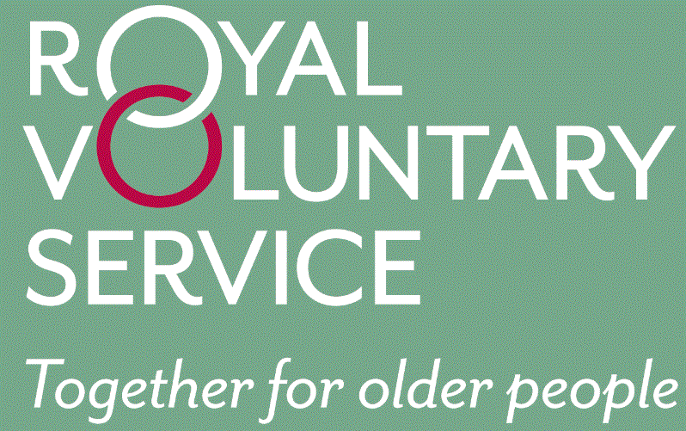
New Service starts Tuesday 30th May 2017
Community Voluntary Transport Service to Pleasington Crematorium
‘Coordinated by the Royal Voluntary Service, delivered by Local Volunteer Drivers’
Providing door-to-door journeys for people who are unable to use either their own transport or public transport, designed to help tackle social exclusion for residents who have no other means of travel.

SERVICE: For passengers visiting Pleasington Crematorium, Blackburn providing a transport alternative for when the Number 39 bus service is withdrawn on Friday 26th May 2017.

ELIGIBILITY: You can join the scheme if you are 50+ and unable to access public or private transport for your journey.

COST: Mileage £0.60p per mile (minimum charge per journey £4.00). Passengers may be accompanied at no extra charge.

PLEASE TURN OVER FOR THE SERVICE USER STEP BY STEP GUIDE
SERVICE USER
STEP BY STEP GUIDE
Step one – Request an application form from RVS by calling 01200 442513. Once completed, return the application form to:
RVS
Community Transport
41A Moor Lane
Clitheroe
Lancashire
BB7 1BE

Step Two – To book a journey call the RVS office on 01200 442513. Bookings should ideally be made 3 days in advance of the journey. Normal office hours are Monday – Thursday 09:30-13:30. If no-one is available to take your call, please leave an answerphone message.

Step Three – RVS will try and supply you with a driver. Note: As a charitable organisation the service offered is not a taxi service. All drivers are volunteers and we rely on their good will and availability. We will try our hardest to supply a driver but this may not always be possible.

Step Four – Journeys will be charged at just £0.60p per mile (minimum charge per journey £4.00). Invoices will be sent each month for journeys which took place in the previous month. NOTE: RVS charge for the total mileage our volunteers incur in taking you on your journey inclusive of the distance from their home to your home and back, we also reserve the right to make a cancellation charge of £3.00 if you cancel a previously arranged journey with less than 3 days’ notice in avoidable circumstances.

For further information, please contact the RVS Transport Office on 01200 442513 or email mia.parkinson@royalvoluntaryservice.org.uk

